Con
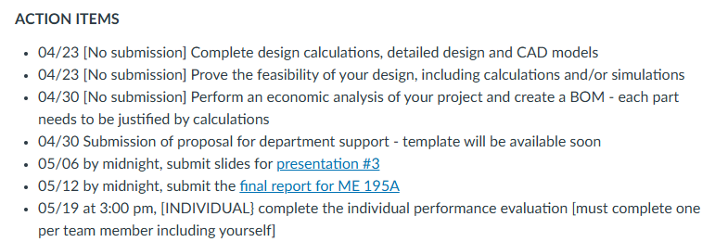
PARTS: https://www.reliableparts.com/refrigerator-parts.html

Note: Let’s really try to complete as much of this stuff as possible by the end of this week. We should have some updates before our meeting with Yi on Wednesday. When we meet with Yi we should confirm how serious these deadlines are (in particular the 4/30 deadline).
Heat transfer: Isabel
GOAL: To size the blocks/fins, determine the ballpark of fan cfm to choose a fan, and calculate the typical money saving
- Detailed Ice volume calculations (Finished)
- Calculate fan CFM and fin size (Finished but professor to review)
- Calculate how long it takes for ice to freeze
  - How much energy and money it requires

Refrigeration: Brent
GOAL: To either prove that the current refrigeration components will work for our application or determine new components to purchase that will

Some possible leading questions:
- Can we switch between the regular refrigerator cooling mode in which the supply temperature is around 2C(may want to update this supply temp in the future idk) to the pre passive cooling mode where the freezer must be at less than 0 degrees for the ice to freeze?
- What is the criteria for sizing the compressor and coils?
  - Are there catalogs like in 183 for the rooftop units
  - Do we need to upsize the components that are existing in the refrigerator since we are adding the freezer compartment (the supply temp is changing)

- How to size coils, fans, compressor, valve, etc?
- Use thermodynamic schematic, temperature and pressures at each location
- Find appropriate components with the specs?

Existing Refrigerator stuff: Caleb
Note: We need this ASAP for other parts of the progress
GOAL: Try to open up the refrigerator and find the existing refrigeration components (model numbers and take pictures) and take additional measurements for Kalino’s CAD model
- Where is the vent currently located
- Can you find the fan? I could not find a fan
- What is the spacing of the shelf adjusting rails? From what distance to the top/bottom do they start
- What’s the exact height of the drawer

Mechatronics/Sensors: Matthew
GOAL: Determine which sensors and microcontroller we want to purchase, figure out how it will be connected and create a circuit diagram

- We need to make a circuit diagram that includes the fans, compressor, microcontroller, and sensors
- What microcontroller are we going to use?
  - Spare PICO?
  - Arduino?
  - Another?
  - esp32
- How is the microcontroller going to be powered
  - We will prob need to step down the voltage from the wall power supply
  - Do we need a transformer?
- What type of temperature sensor should we use?
  - Thermistors, probably three of them(cheaper and more accurate than thermocouple)
    - Two for regular temperature sensoring
    - One for the defrost mechanism
- Where should the temperature sensors be located?
  - Defrost Mechanism
    - Thermistor attached to the evaporator coils(along with defrost heater)https://www.edn.com/defrost-thermistors/#:~:text=Defrost%20Sensor%20%26%20Control%20System,evaporator%20to%20sense%20its%20temperature.
    - Defrost heater can be connected indirectly to the ESP32 using relay IN pin or solid state relay module
  - Top of fridge
  - Towards bottom of fridge

- How will the temperature sensor be installed?

It’d be great to find a research paper that has different CFD simulations for vent locations and proves which one is best.

Mechanical Design: Kalino
GOAL: Create a detailed CAD drawing of the detailed design and put some thought into the retrofit modifications
After the CAD matches the refrigerator some extra things to consider are:
- How are we going to separate the freezer and refrigerator so that we can still access both but the user won’t see the freezer stuff (removable panel?)
- What are our options for mounting the fans

Other stuff we need to figure out: (Isabel will get started on this and anyone else who finishes their stuff pls help with)
- Best vent locations for optimal airflow
- Where are vents typically located in refrigerators
- Is it possible to try to do a cfd simulation in Ansys

